**Chapter Six**

**Conclusion and future work**

# 5.1 Introduction.

This chapter will conclude the system; it talk about two section: - The first section introduce the conclusion of the system. The second section will talk about the improvements that will be mad in future work.

# Android

Android is a mobile operating system based on a modified version of the Linux kernel and other open source software, designed primarily for touchscreen mobile devices such as smartphones and tablets. Android is developed by a consortium of developers known as the Open Handset Alliance and commercially sponsored by Google. It was unveiled in November 2007, with the first commercial Android device, the HTC Dream, being launched in September 2008.

Most versions of Android are proprietary. The core components are taken from the Android Open Source Project (AOSP), which is free and open-source software (FOSS) primarily licensed under the Apache License. When Android is installed on devices, ability to modify the otherwise FOSS software is usually restricted, either by not providing the corresponding source code or preventing reinstallation through technical measures, rendering the installed version proprietary. Most Android devices ship with additional proprietary software pre-installed most notably Google Mobile Services (GMS)[14] which includes core apps such as Google Chrome, the digital distribution platform Google Play, and associated Google Play Services development platform.

Android was founded in Palo Alto, California, in October 2003 by Andy Rubin, Rich Miner, Nick Sears, and Chris White.Rubin described the Android project as having "tremendous potential in developing smarter mobile devices that are more aware of its owner's location and preferences".[21] The early intentions of the company were to develop an advanced operating system for digital cameras, and this was the basis of its pitch to investors in April 2004.[22] The company then decided that the market for cameras was not large enough for its goals, and five months later it had diverted its efforts and was pitching Android as a handset operating system that would rival Symbian and Microsoft Windows Mobile.

Android is open to everyone: developers, designers and device makers. That means more people can experiment, imagine and create things the world has never seen.

# Firebase

Firebase is a Backend-as-a-Service (Baas). It provides developers with a variety of tools and services to help them develop quality apps, grow their user base, and earn profit. It is built on Google’s infrastructure.

Firebase is categorized as a NoSQL database program, which stores data in JSON-like documents.

Vvvvv3`

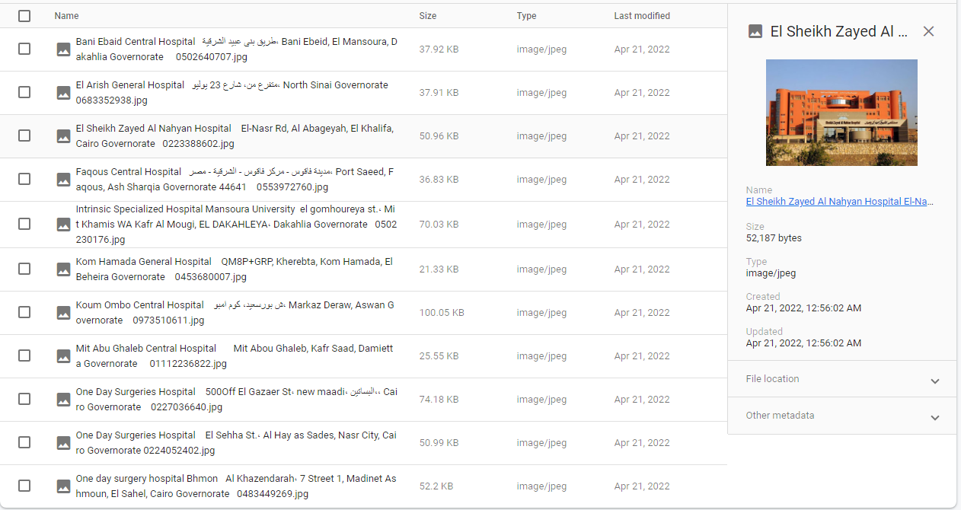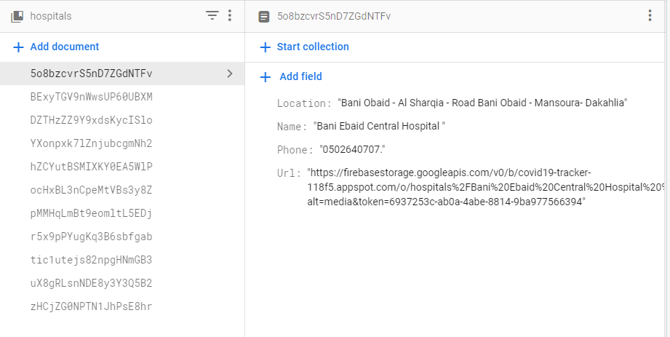Every hospital has data (Name- Location - Phone- Url Image)

every hospital has Image Url and invoked in our app in figruer()

1. 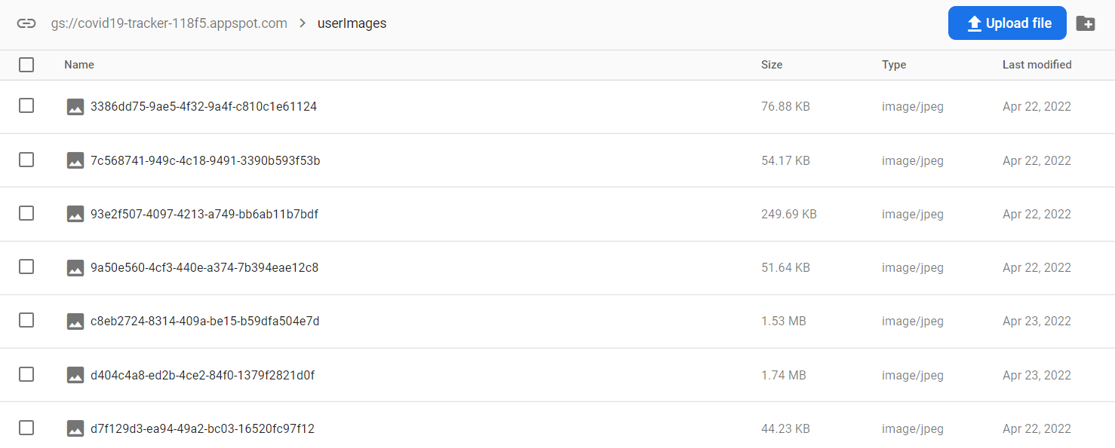Firebase Storage  
   Cloud Storage for Firebase is built for app developers who need to store and serve user-generated content, such as photos or videos. Cloud Storage for Firebase is a powerful, simple, and cost-effective object storage service built for Google scale. The Firebase SDKs for Cloud Storage add Google security to file uploads and downloads for your Firebase apps, regardless of network quality. We use storage mostly to save data. Like the user photo we upload and save it in storage then use it in our app in any time.   
     
   naser lw 7abb tdef 7aga

# Machine Model

Here we will talk about machine learning model and what were we use in our project .

We used the CNN (convolutional neural network) to classify the masked and no masked faces.

Now what is the CNN ?

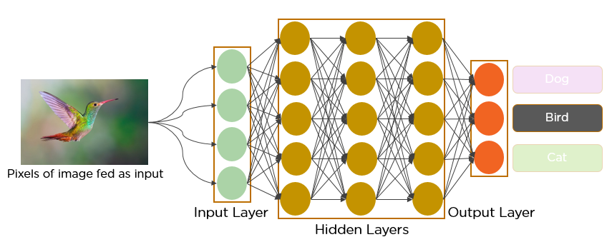Convolutional neural networks are a specialized type of artificial neural networks that use a mathematical operation called convolution in place of general matrix multiplication in at least one of their layers. They are specifically designed to process pixel data and are used in image recognition and processing.

In deep learning, a **convolutional neural network** (**CNN**, or **ConvNet**) is a class of [artificial neural network](https://en.wikipedia.org/wiki/Artificial_neural_network) (**ANN**), most commonly applied to analyze visual imagery.CNNs are also known as **Shift Invariant** or **Space Invariant Artificial Neural Networks** (**SIANN**), based on the shared-weight architecture of the convolution kernels or filters that slide along input features and provide translation-[equivariant](https://en.wikipedia.org/wiki/Equivariant_map" \o "Equivariant map) responses known as feature maps.Counter-intuitively, most convolutional neural networks are only [equivariant](https://en.wikipedia.org/wiki/Equivariant_map), as opposed to invariant, to translation.They have applications in image and video recognition,recommender systems,image classification,image segmentation,medical image analysis,natural language processing,brain–computer interfaces,and financial time series.

Architecture of CNN

A convolutional neural network consists of an input layer, hidden layers and an output layer. In any feed-forward neural network, any middle layers are called hidden because their inputs and outputs are masked by the activation function and final convolution. In a convolutional neural network, the hidden layers include layers that perform convolutions. Typically this includes a layer that performs a dot product of the convolution kernel with the layer's input matrix. This product is usually the Frobenius inner product , and its activation function is commonly ReLU. As the convolution kernel slides along the input matrix for the layer, the convolution operation generates a feature map, which in turn contributes to the input of the next layer. This is followed by other layers such as pooling layers, fully connected layers, and normalization layers.

Now we underused the Architecture of CNN we can dive in what are we done ?

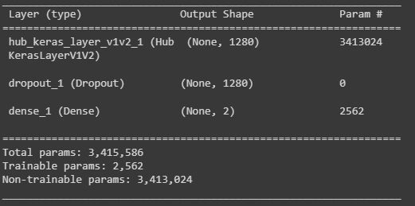

We Have 3415856 node in our CNN and we train our model with our dataset .

Our dataset Consists of two categories (Masked people –No masked people) and has 3850 photo

This screens from our dataset

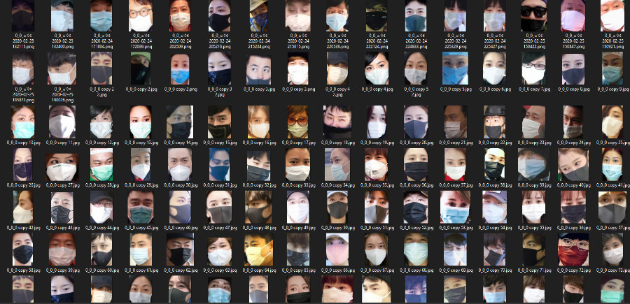

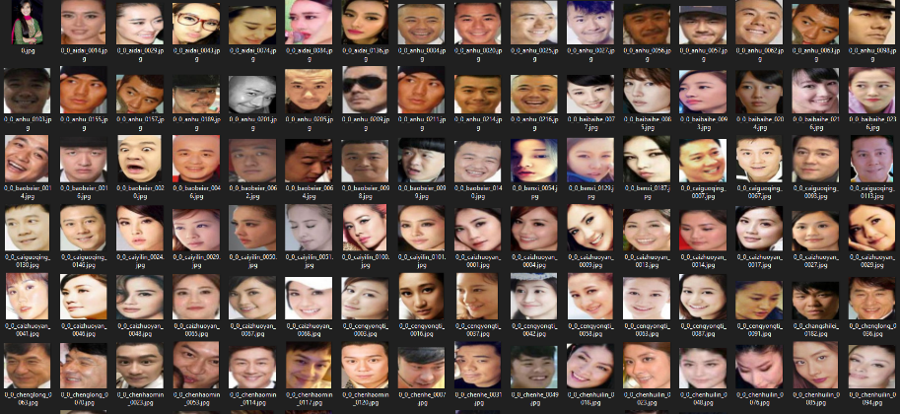

After this model we can get this results and this accuracy

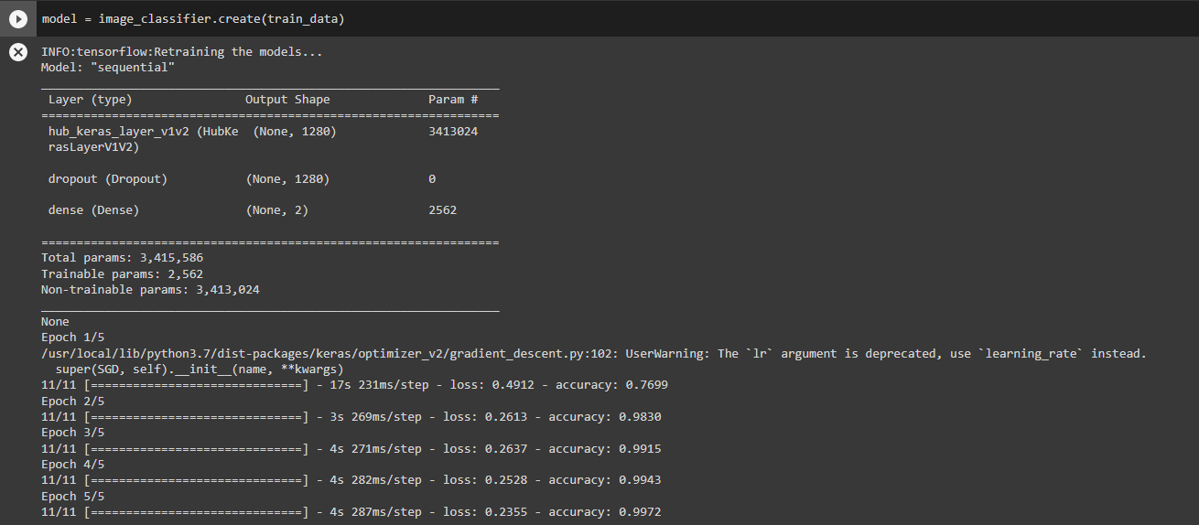

We get the last accuracy 0.9972 on training this model after 5 epoch and each epoch has 11cycle.

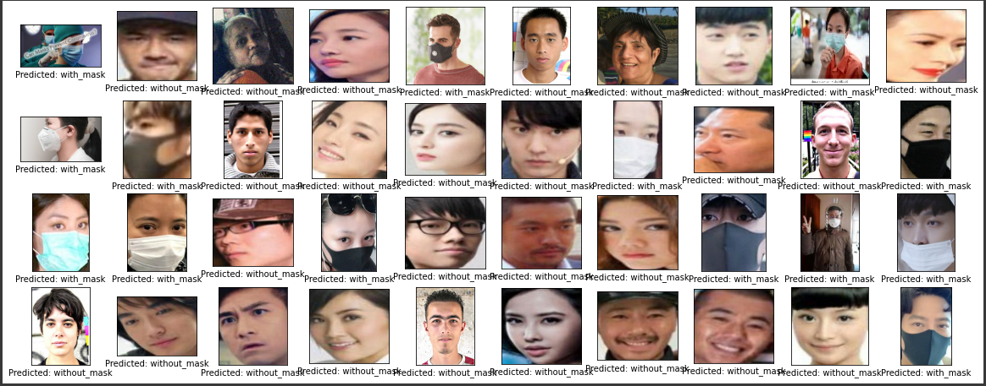

In figure ( ) we can see the test data and the prediction of model on it , we have very good accuracy .

Now should transform this model form tensor flow to tensor flow lite to work in mobile phone  
we can now used this model in our application.

# API

# Rerofit

# 5.2 Conclusion:

Design and construction of

# 5.3 Future Work